3A Biological Sciences

Test 2 – Homeostasis

Name _______________________________________________________________________

Total Score /55marks

Part 1 - Multiple choice answers /25 marks
Indicate the correct answer for each question below.

1.[A] [B] [C] [D] | 6. [A] [B] [C] [D] | 11.[A] [B] [C] [D] | 16.[A] [B] [C] [D] | 21.[A] [B] [C] [D]
2.[A] [B] [C] [D] | 7. [A] [B] [C] [D] | 12.[A] [B] [C] [D] | 17.[A] [B] [C] [D] | 22.[A] [B] [C] [D]
3.[A] [B] [C] [D] | 8. [A] [B] [C] [D] | 13.[A] [B] [C] [D] | 18.[A] [B] [C] [D] | 23.[A] [B] [C] [D]
4.[A] [B] [C] [D] | 9. [A] [B] [C] [D] | 14.[A] [B] [C] [D] | 19.[A] [B] [C] [D] | 24.[A] [B] [C] [D]
5.[A] [B] [C] [D] | 10.[A] [B] [C] [D] | 15.[A] [B] [C] [D] | 20.[A] [B] [C] [D] | 25.[A] [B] [C] [D]

Part 2 – Short answer /30 marks
Write your response in the space provided for each question. Answer all the questions.

- The homeostasis of the internal environment is a major requirement of all living organisms.

  - State why the following conditions must be controlled by the process of homeostasis for the effective functioning of the organism.
Carbon dioxide

Salts

(4 marks)

  - Marine and freshwater fish balance the loss and gain of salt and water using different mechanisms depending on their environment.

Complete the table below the comparing the processes that fish use to maintain water and salt balance.
 | Freshwater fish | Saltwater fish
Gills

Urine

Drinking

(6 marks)

- A student collected leaves from different plants from different environments. On her way back to the laboratory the labels on the specimens came off. She took cross sections (drawn below) of some of the leaves and looked at them under a microscope.

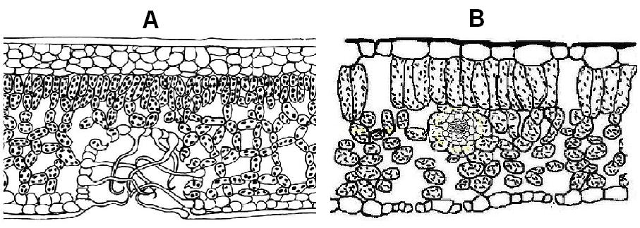

Diagram A - Bgqhrsnog (2006) Cross section through a xerophyte leave. http://commons.wikimedia.org/wiki/File:Xerophyten_-_Blattanatomie.png. Accessed 5 October, 2009

Diagram B - Maksim (2006) File:Blad dwarsdoorsnede.jpg. http://commons.wikimedia.org/wiki/File:Blad_dwarsdoorsnede.jpg. Accessed 5 October 2009

  - Which plant is adapted to survive in arid conditions?
(1 mark)

  - Briefly describe three adaptations evident in this leaf cross section that support this inference.( Mark first three only)
(3 marks)

  - Describe a physiological adaptation of an arid climate plant:
(2 marks)

  - Maintenance of water balance and moderate temperature is vital for the functioning of a plant. Describe why a plant needs to maintain these two factors within an acceptable level in order to continue functioning normally.

(4 marks)

- The red kangaroo (Macropus rufus) is a large marsupial that lives in the arid and semi arid regions of central Australia. They feed on native grasses in these regions, moving great distances to find suitable food and water sources.

A study on red kangaroos demonstrated that at high temperatures (40 - 44 ºC) and moderate humidity they regulated their body temperature well by increasing respiratory rate, while maintaining pulse rate and body temperatures at normal levels. When the humidity was increased the animals became heat stressed, with an increase in pulse rate and a 2ºC increase in body temperature.

  - Explain how an increase in breathing rate allowed the kangaroo to modulate their body temperature.
(2 marks)

  - Explain why increasing humidity affected the kangaroo’s abilities to control their body temperature this way.
(2 marks)

  - Describe one way red kangaroos may lose water and an adaptation they may have to reduce water loss by this method.
(2 marks)

  - Red kangaroos have been observed grazing on grasses in “moisture run-on” zones (areas where moisture accumulates after rain) in their arid habitat. They also feed more around dusk and dawn, which coincides with higher transpiration rates in the plants they feed on.

Discuss how these behaviours are adaptations to an arid habitat.

(4 marks)

